|  |
| --- |
| Experiment No.1 |
| To demonstrate the various online tools available to create block, block chain and  Wallet |
| Date of Performance: |
| Date of Submission: |

**Aim**: To demonstrate the various online tools available to understand block, block chain and Wallet

**Objective**: To make use of various online tools to understand the concept of blockchain

**Theory**: A blockchain is “a distributed database that maintains a continuously growing list of ordered records, called blocks.” These blocks “are linked using cryptography. Each block contains a cryptographic hash of the previous block, a timestamp, and transaction data. A blockchain is a decentralized, distributed and public digital ledger that is used to record transactions across many computers so that the record cannot be altered retroactively without the alteration of all subsequent blocks and the consensus of the network.”

While blockchain is still largely confined to use in recording and storing transactions for cryptocurrencies such as Bitcoin, proponents of blockchain technology are developing and testing other uses for blockchain, including these:

* **Blockchain for payment processing and money transfers.** Transactions processed over a blockchain could be settled within a matter of seconds and reduce (or eliminate) banking transfer fees.
* Blockchain for monitoring of supply chains. Using blockchain, businesses could pinpoint inefficiencies within their supply chains quickly, as well as locate items in real time and see how products perform from a quality-control perspective as they travel from manufacturers to retailers.
* Blockchain for digital IDs. Microsoft is experimenting with blockchain technology to help people control their digital identities, while also giving users control over who accesses that data.
* Blockchain for data sharing. Blockchain could act as an intermediary to securely store and move enterprise data among industries.
* Blockchain for copyright and royalties protection. Blockchain could be used to create a decentralized database that ensures artists maintain their music rights and provides transparent and real-time royalty distributions to musicians. Blockchain could also do the same for open source developers.
* Blockchain for Internet of Things network management. Blockchain could become a regulator of IoT networks to “identify devices connected to a wireless network, monitor the activity of those devices, and determine how trustworthy those devices are” and to

“automatically assess the trustworthiness of new devices being added to the network, such as cars and smartphones.”

* Blockchain for healthcare. Blockchain could also play an important role in healthcare: “Healthcare payers and providers are using blockchain to manage clinical trials data and electronic medical records while maintaining regulatory compliance.”

The blockchain is a chain of data blocks. Each block can be thought of as a page in a ledger. The individual blocks are composed of several components. Roughly these can be differentiated into the head of the block (block header) and his body (block body).

Block header

The head of the block is divided into six components:

* the version number of the software
* the hash of the previous block
* the root hash of the Merkle tree
* the time in seconds since 1970–01–01 T00: 00 UTC
* the goal of the current difficulty
* the nonce

# Wallet

A blockchain wallet is a cryptocurrency wallet that allows users to manage different kinds of cryptocurrencies—for example, Bitcoin or Ethereum. A blockchain wallet helps someone exchange funds easily. Transactions are secure, as they are cryptographically signed. The wallet is accessible from web devices, including mobile ones, and the privacy and identity of the user are maintained. So a blockchain wallet provides all the features that are necessary for safe and secure transfers and exchanges of funds between different parties.

A blockchain wallet consists of:

* 1. Cryptocurrency (e.g., Bitcoin, Ether etc.)
  2. Public key of the participants in the blockchain
  3. Private key of the participant in the blockchain

Some of the example of wallets are MyEtherWallet, MetaMask, Bitcoin wallet etc.

# Process:

Step 1. Visit the website https://guggero.github.io/blockchain-demo/#!/tokens

Step 2. Click on the block option tab to create a block with a particular information

Step 3. Click on the block chain option tab to create a block chain. For every block give certain input data and click on the mine tab to create a hash of the block

Step 4. Repeat step 3 for all the remaining blocks

Step 5. Click on the Distributed option tab to create distributed block chain

Step 6. Change the data field of a block on any Peer and then mine it to create a new block.

Step 7. Copy the nonce of the mined block and paste it into block (at the same level) in another peer. Also change the data field of this block as per data field. Do not click on the mine

Step 8. Repeat step 6-7 for every other blocks to form a distributed block chain.

To create a wallet in Blockchain.com

1. Go to Blockchain.com on your computer or smartphone and click on either Sign Up or Get Started.
2. You can also click on the Log In button then click on Sign up Now if you're returning to the site after a previous visit.
3. Each path will lead you right to the Create Wallet page. Once there, click on Create Wallet. Creating a wallet is the first step towards opening a Blockchain.com account.
4. Enter your email address in the space provided. Make sure that it&#39;s a working email address that you currently have access to. You'll need it to verify your email address.
5. Enter a strong password, and confirm the password. You can ask your browser to suggest a strong password and to save it for you. Select your country if it&#39;s not already selected automatically. Review the information in the consent section and check the box when you're done. Click Create Wallet.

Creating Wallet using ‘MyEtherWallet.com’ Step 1. Go to website MyEtherWallet | MEW

Step 2. Click on the option ‘Create A New Wallet’

Step 3. Create Wallet using Software or any suitable method

Step 4. If wallet is to be created using Software, select ‘Mnemonic Phrase’ option to create wallet

Step 5. Note down all the Mnemonic Phrase and then click on ‘I wrote Down’ Button Step 6. Verify the Mnemonic Phrase as asked on the web page

Step 7. Once verification is successful, the wallet gets created. Step 8. The Wallet can be accessed through MyEtherWallet.com

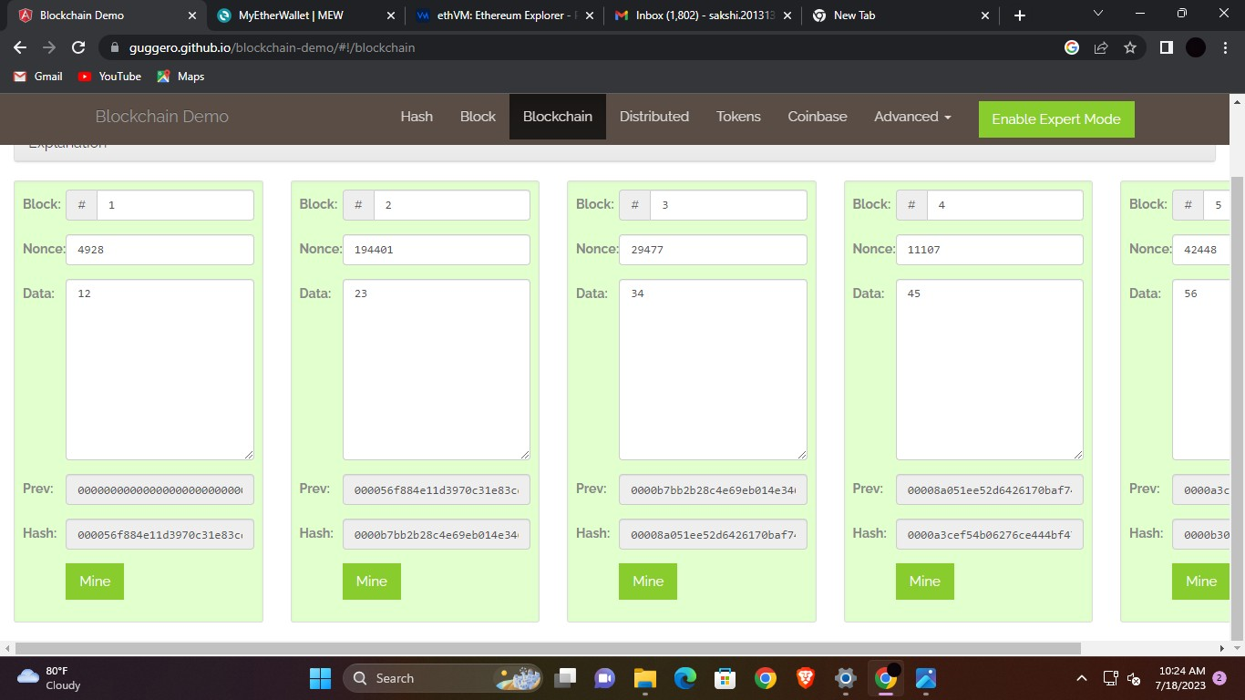

# E-Wallet:-

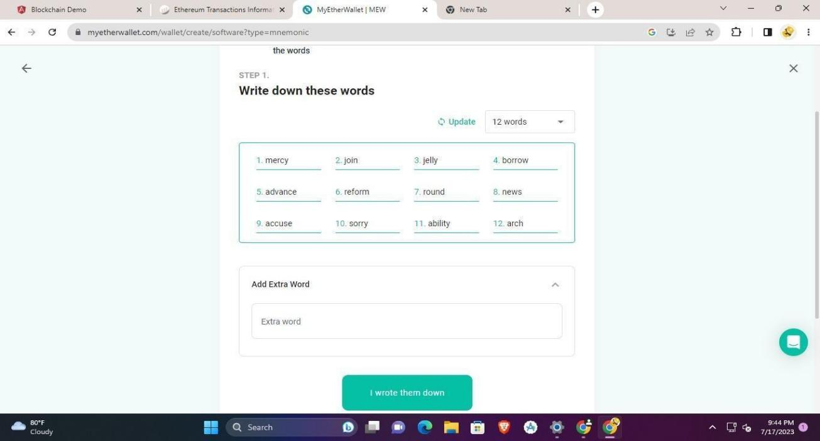

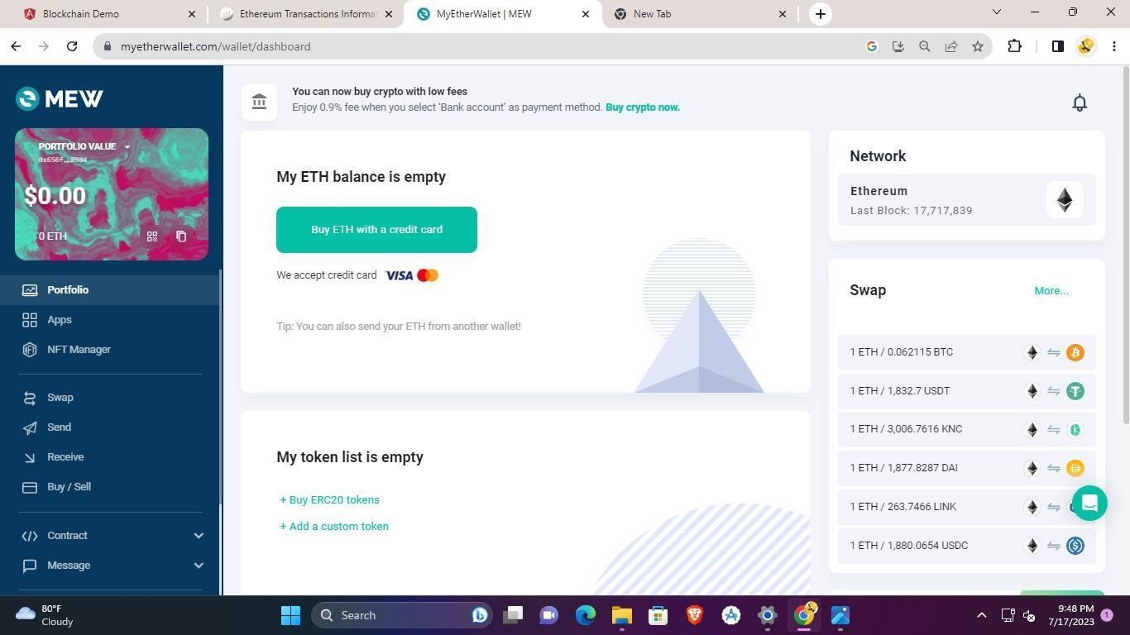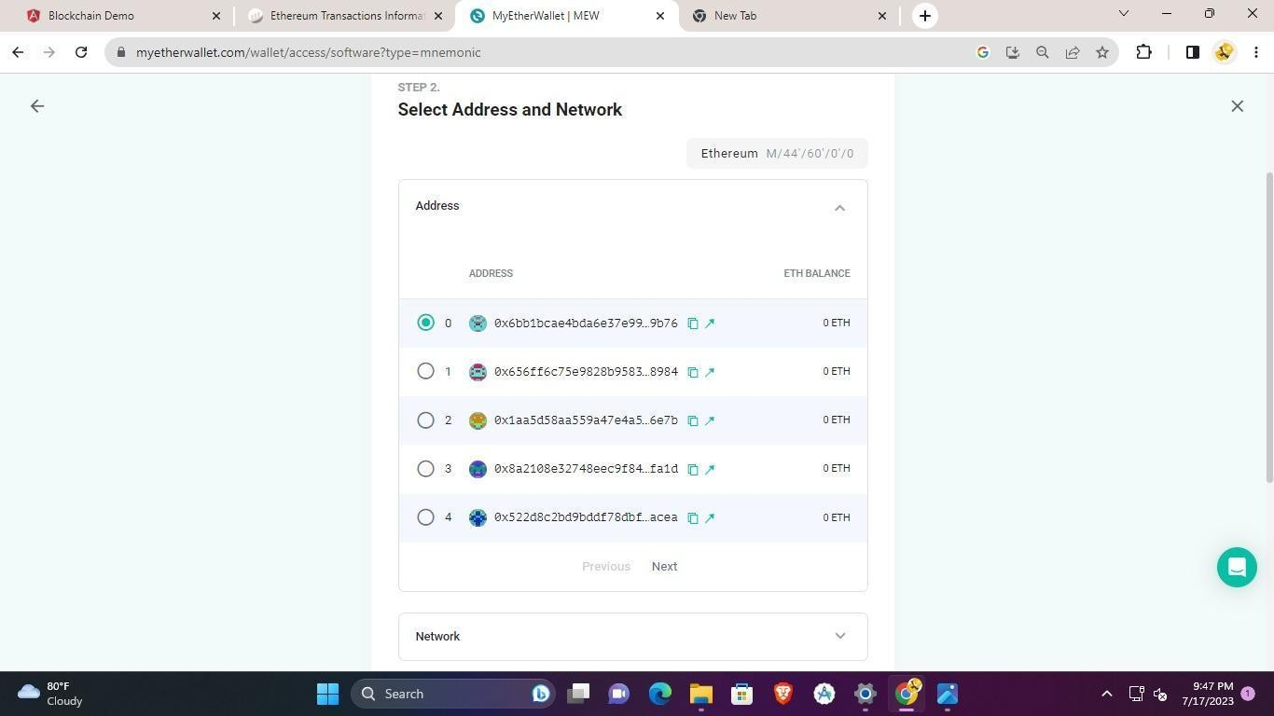

**Conclusion:-**

In conclusion, various online tools and resources offer valuable insights into blockchain technology. Block explorers like Blockchain.info provide real-time visibility into transactions and block data. Educational platforms like Coursera and Udemy offer courses explaining blockchain fundamentals. Wallet services such as Coinbase and Trust Wallet enable users to securely store and manage cryptocurrencies. Overall, these online tools serve as essential resources for comprehending the intricacies of blockchain, blocks, and digital wallets, empowering individuals to navigate the world of cryptocurrencies and decentralized technology with confidence.